Design the platform layout and create a database to store product information:

Designing a platform layout and creating a database to store product information involves several steps.

PLATFORM LAYOUT DESIGN:

* Start by designing the user interface for your platform. Consider the overall look and feel, user experience, and navigation.
* Create wireframes or mock-ups to visualize the layout.
* Implement a user authentication system for user registration and login.
* Consider using industry-standard authentication protocols like OAuth or OpenID for enhanced security.
* Design a dashboard where users can access various features and functions of the platform.
* Organize it logically, such as with sections for products, user profiles, settings, and more.
* Create a page to display a list of products. Include features like search, filters, and sorting options.
* Design a detailed view of a product that shows information like product name, description, price, and images.
* If the platform is for sellers, create an admin panel for managing products, orders, and user accounts.
* Implement a shopping cart where users can add and manage the products they want to purchase.
* Design a checkout page for users to enter their shipping and payment information.

DATABASE DESIGN:

User Table:

Fields: UserID (Primary Key), Username, Email, Password (hashed), etc.

Product Table:

Fields: ProductID (Primary Key), ProductName, Description, Price, StockQuantity, CategoryID (Foreign Key), SellerID (Foreign Key), etc.

Category Table:

Fields: CategoryID (Primary Key), CategoryName, Description, etc.

Order Table:

Fields: OrderID (Primary Key), UserID (Foreign Key), OrderDate, TotalAmount, ShippingAddress, etc.

OrderItem Table:

Fields: OrderItemID (Primary Key), OrderID (Foreign Key), ProductID (Foreign Key), Quantity, UnitPrice, Subtotal, etc.

Seller Table (if applicable):

Fields: SellerID (Primary Key), SellerName, SellerDescription, ContactInfo, etc.

Image Table (for product images):

Fields: ImageID (Primary Key), ProductID (Foreign Key), ImageURL, etc.

Review Table:

Fields: ReviewID (Primary Key), ProductID (Foreign Key), UserID (Foreign Key), Rating, ReviewText, ReviewDate, etc.

CODE:

<!DOCTYPE html>

<html lang="en">

<head>

<meta charset="UTF-8">

<meta name="viewport" content="width=device-width, initial-scale=1.0">

<title>Artisanal E-Commerce</title>

<link rel="stylesheet" href="styles.css">

</head>

<body>

<header>

<h1>Welcome to Artisanal Marketplace</h1>

<nav>

<ul>

<li><a href="#home">Home</a></li>

<li><a href="#products">Products</a></li>

<li><a href="#cart">Cart</a></li>

</ul>

</nav>

</header>

<section id="home">

<h2>Discover Unique Handcrafted Items</h2>

<p>Explore our collection of artisan-made products.</p>

</section>

<section id="products ">

<h2>Featured Products</h2>

<div class="product-gallery">

<!-- Display product images, names, and prices -->

<div class="product">

<img src="product1.jpg" alt="Product 1">

<h3>Artistic Jewelry</h3>

<p>$50.00</p>

<button>Add to Cart</button>

</div>

<!-- Add more products -->

</div>

</section>

<section id="cart" >

<h2>Your Shopping Cart</h2>

<!-- Display cart items and total -->

<div class="cart-items">

<!-- Display cart items -->

</div>0

<p>Total: $[Total Amount]</p>

<button>Proceed to Checkout</button>

</section>

<footer>

<p>&copy; 2023 Artisanal Marketplace. All rights reserved.</p>

</footer>

</body>

</html>

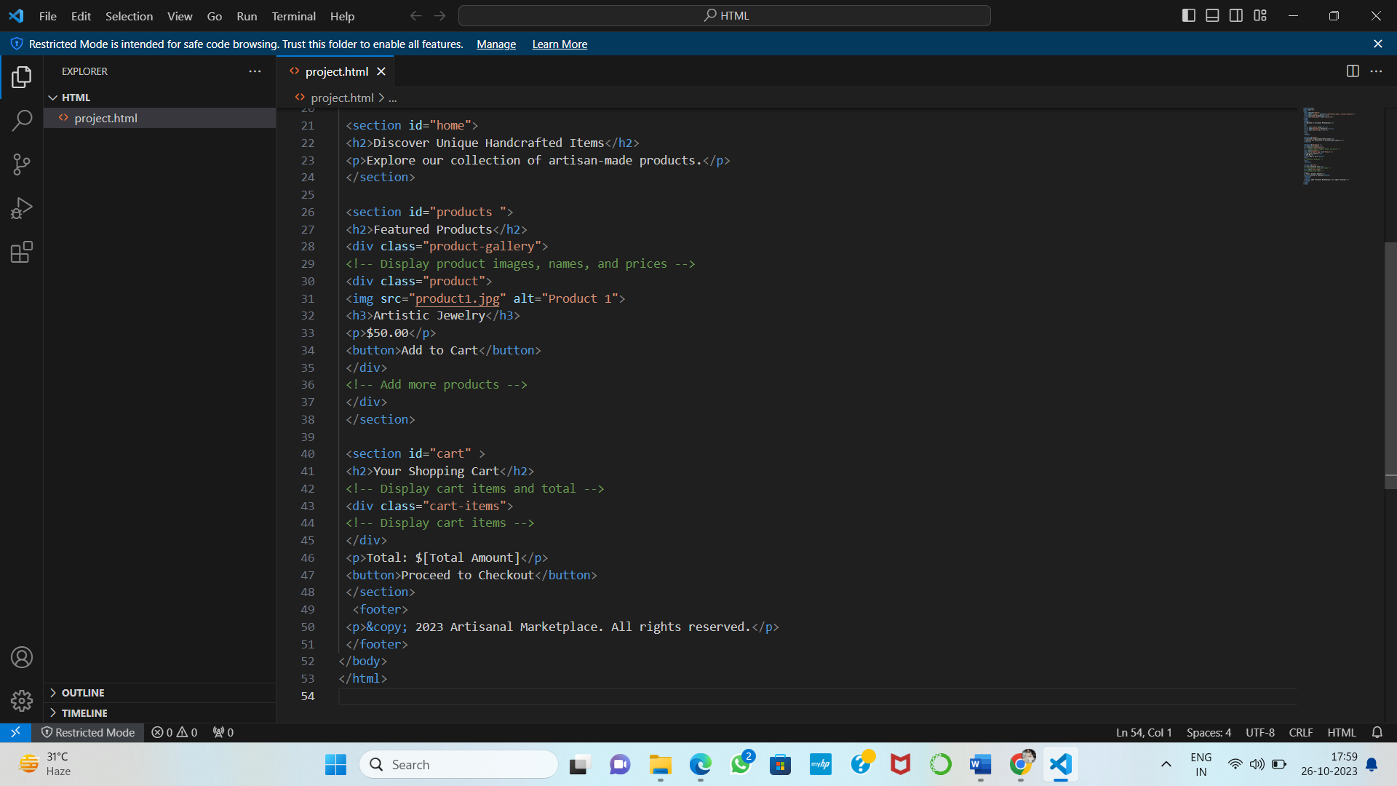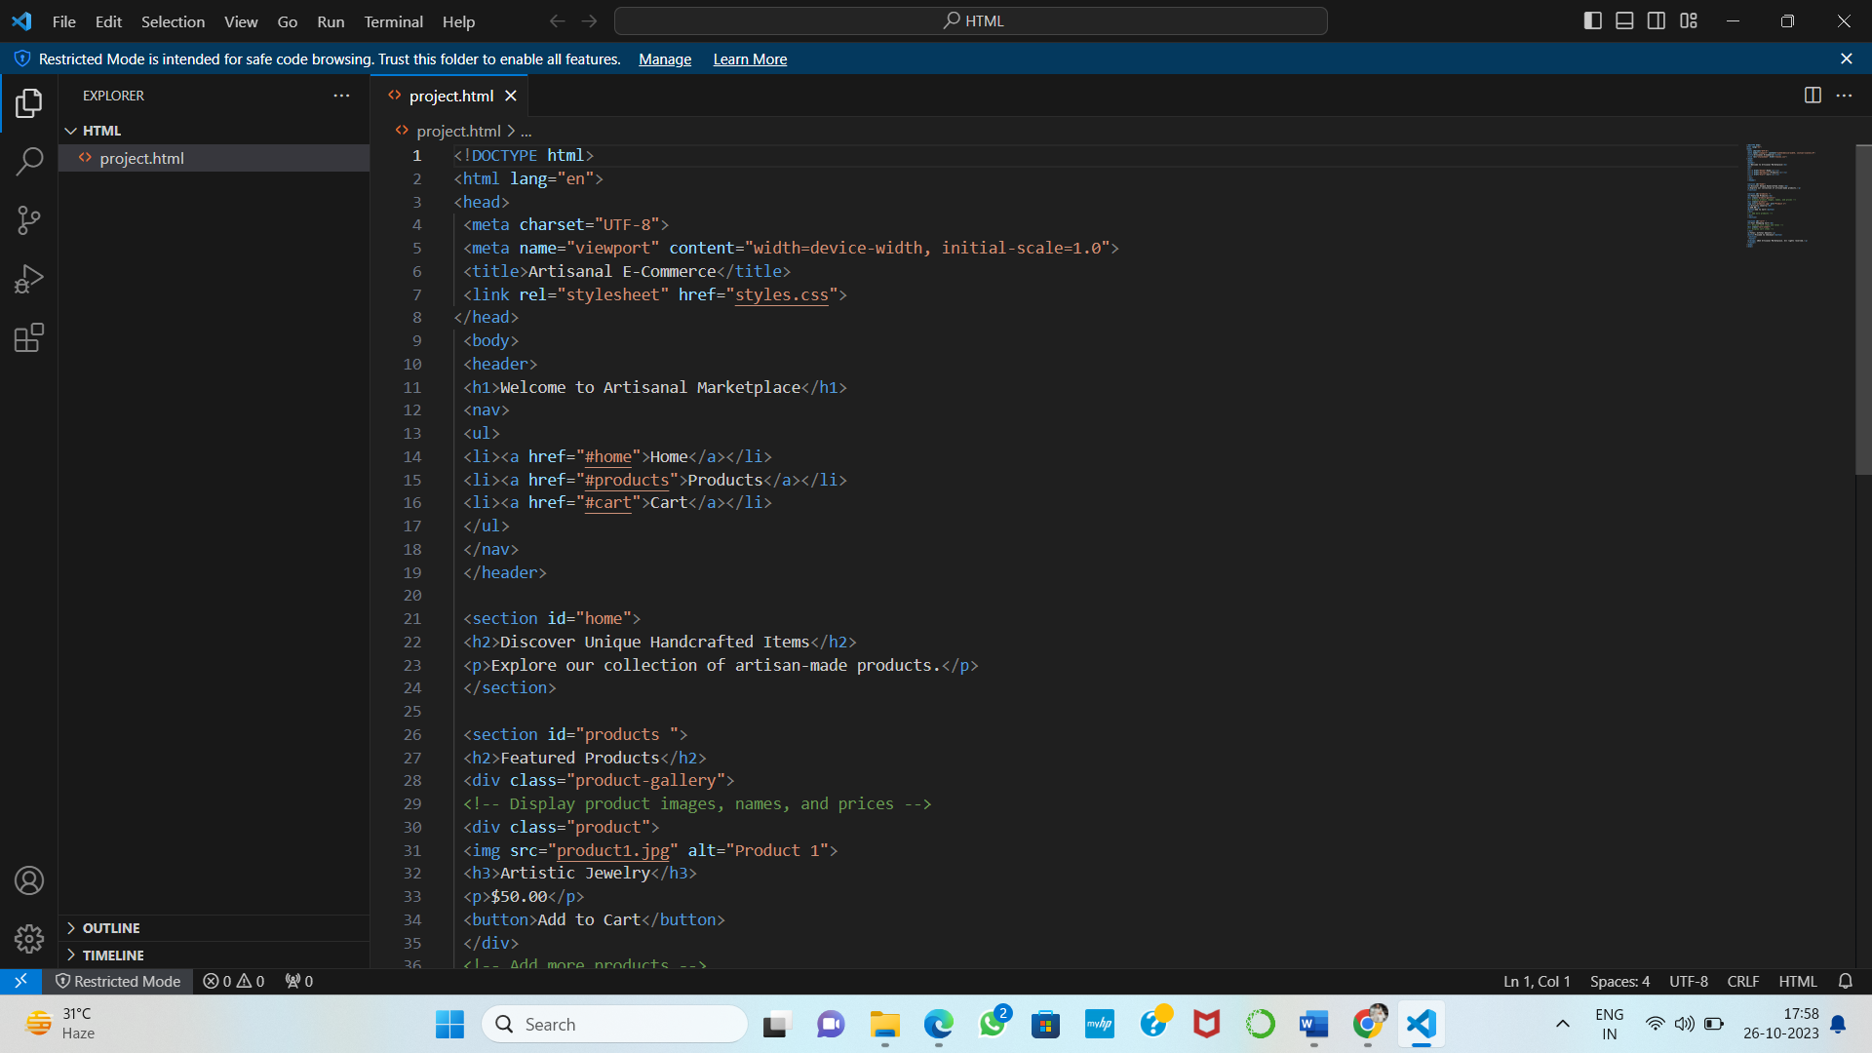

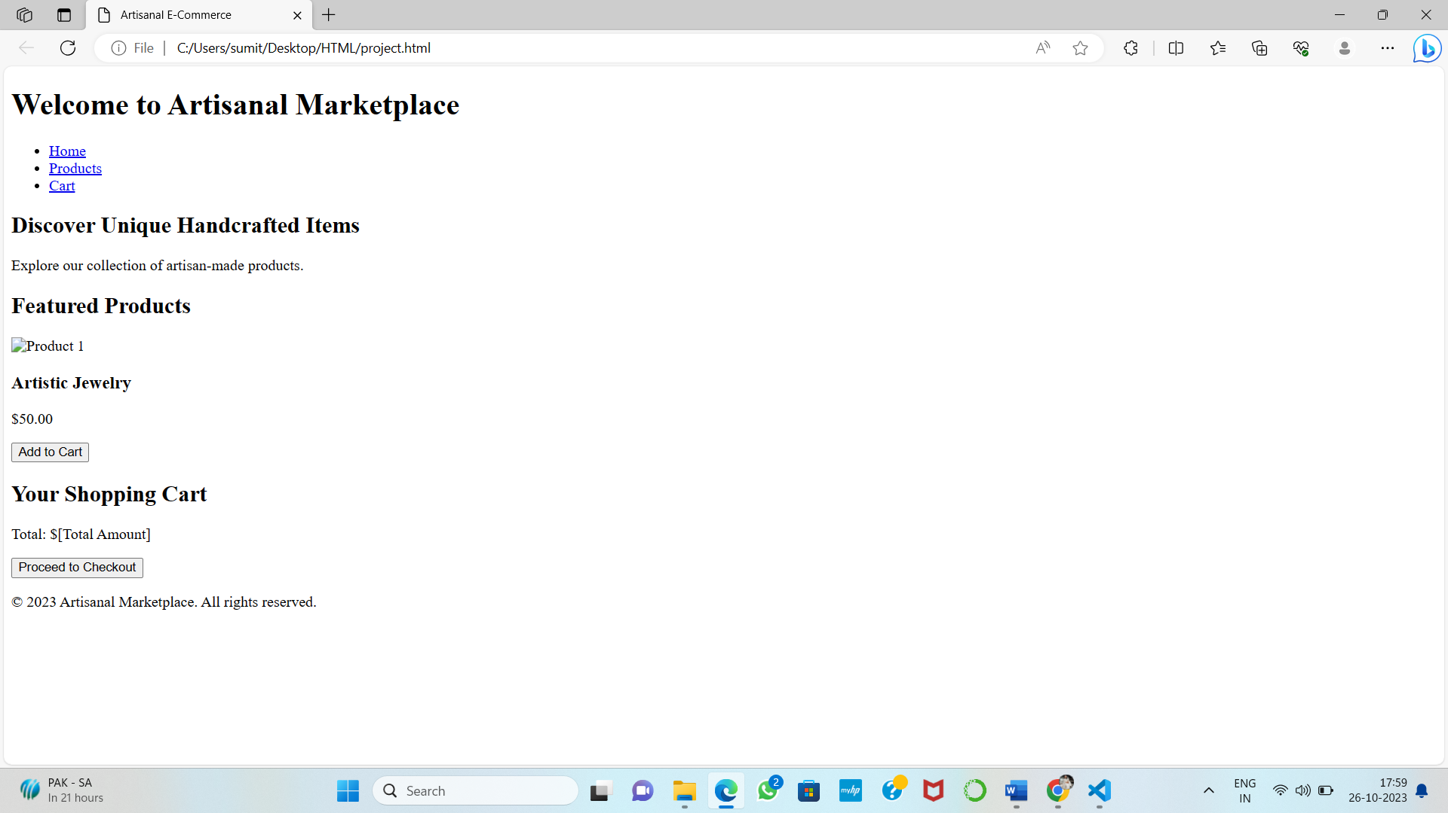OUTPUT: